Missionary Newsletter
  - Greater Emmanuel Temple Church
Home Mission  GETC Outreach  The Greater Emmanuel Temple (GETC) missionaries with the generosity of the members of Greater Emmanuel Temple and others were able to bless so many over the last three months.  One expectant mother and her family received a dresser with a changing top, a 4-in-1 crib, a quick fold trio system, newborn clothes and pampers. Many thanks to our donating partner Mitzvah Circle. | An unemployed lady received a seventy-five-dollar monetary donation to help her with expenses.  Shoes, pampers and other clothing items were donated to the church and members of the community.  Missionaries volunteered at food bank drives and clothing closets.  Transportation was provided for those who needed a ride to church or other appointments.  Food and gas cards and food boxes were given to help members of the church and community. |  | Missionaries continue to participate in the Operation Smile initiative. It is an ongoing campaign to encourage people unable to attend services or confined to their homes or facilities. Operation Smile involves a letter and or card campaign for any resident in a health facility, especially nursing homes, other centers for the elderly and the homebound. Our major goal is to bring a smile to the clients at these institutions.

Don’t Talk About IT! Get Involved!

Our missionaries send out cards and letters, make phone calls, send emails, post encouraging words on Facebook and other social media outlets. Our missionary president, Dr. Stewart, also posts Words of Encouragement on Facebook, Instagram, Twitter and shares inspirational quotes and devotionals with the missionaries and others via text or an email. Missionary Beverly Glasco posts Monday Messages of Encouragement via text as well. In addition, many missionaries participate in ZOOM, YouTube, Facebook Live and other platforms for church services, bible studies and prayer meetings.

Lord willing in June 2022, a trip to Kenya is being planned for those who would like to see the orphanage. If you would like to support us in this endeavor, please send funds to Dr. Stewart by Cash App $SAS2036, Zelle and PayPal at sstew63598@aol.com. Please note funds for global missions. Donations can be mailed to the church as well at 296 Pemberton Road, Kennett Square, PA 19348.

It’s Spring and Resurrection Season. The missionaries and volunteers prepared approximately one hundred and fifty plastic Easter eggs for distribution to the following organizations: thirty eggs and “blessing” packets for the clients of Chester, PA Salvation Army. Each individual packet included two pairs of socks, a daily bread, sanitizer, a bag of popcorn and a drink. Home Mission, Inc. in Kennett Square, PA receive twenty “blessing” bags and food. Churchman Village, a facility for the elderly and those in need of rehabilitation in Newark, Delaware received over one hundred eggs. Each egg contained an encouraging word and candy treats (some eggs had no candy for those who couldn’t take food by mouth).

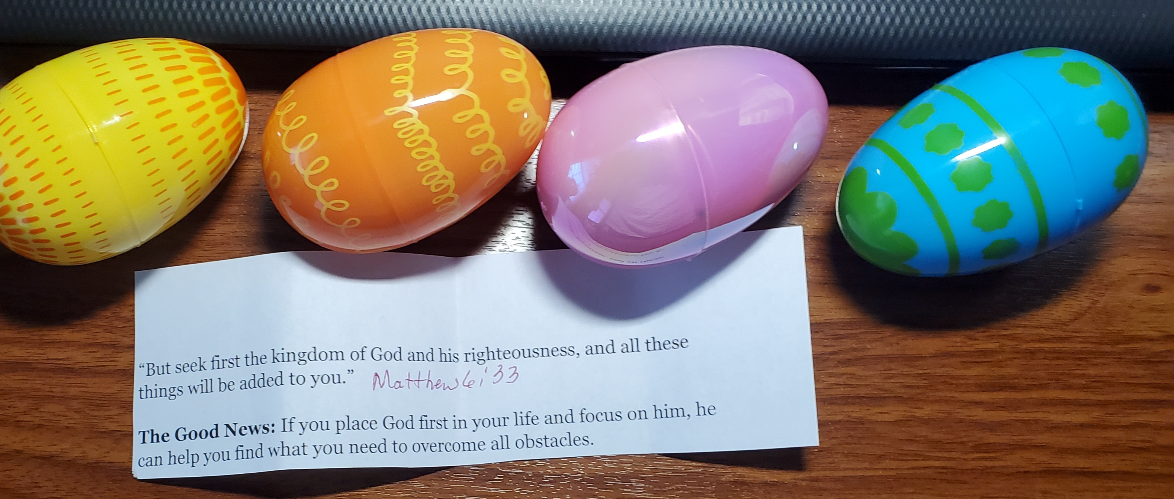
.

Global Missions

Upendo
The missionaries continue to support Upendo, our global mission focus, in collaboration with the Upendo United Foundation. Regina Reithii started this foundation to support an orphanage in Kenya which helps 135 children ranging in age from 3 months to 19 years old. Upendo means “love “in Swahili. Feel free to visit the website to learn more www.upendounitedfoundation.org.
We donated approximately ten boxes of pampers of assorted sizes for the orphanage as well as clothing items such as t-shirts, shoes, and socks. Moreover, we were pleased to donate several boxes of books for their library.

Lord willing in June 2022, a trip to Kenya is being planned for those who would like to see the orphanage. If you would like to support us in this endeavor, please send funds to Dr. Stewart by Cash App $SAS2036, Zelle and PayPal at sstew63598@aol.com. Please note funds for global missions. Donations can be mailed to the church as well at 296 Pemberton Road, Kennett Square, PA 19348.

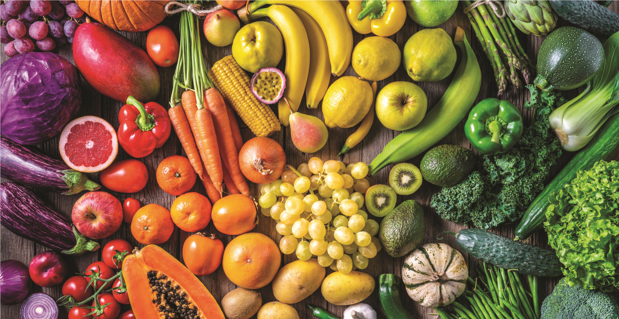  The Best Foods to Boost Springtime  Health and Immunity  Here’s our list of the top eight immunity-boosting foods for spring health:  • Citrus: There are plenty of citrus options during the spring and summer, including grapefruit, oranges, clementine, pineapple, and tangerines. These fruits are high in vitamin C, which can help to reduce the longevity of colds and flu if you happen to get one. Vitamin C also helps produce collagen, a protein that strengthens the blood vessels, ligaments, and muscles necessary for immune system support.  • Spinach: This dark, leafy green is loaded with immunity-boosting zinc. Zinc aids in cell division, cell growth, wound healing, and the breakdown of carbohydrates. • Nuts: Many types of nuts contain zinc, healthy fats, and selenium, a mineral that helps to support immune system health. Brazil nuts have the highest amounts of selenium. Just one Brazil nut contains a full day’s supply of this powerful mineral! • Mushrooms: This fungus has been found in herbal medicine chests for centuries. It increases the production of cells that help fight off infections and it contains polysaccharides, compounds that support the immune system. | • Yogurt: Consuming any type of yogurt that contains probiotics will give you a one-up against colds and flu. Probiotics replenish good strains of bacteria that promote digestive health, which is key to fending off illness and infection.  • Tea: Teas have robust flu-fighting properties known as catechins. Sipping on a nightly cup of herbal tea before bed can boost the metabolism and protect against certain cancers.  • Blueberries: These tiny berries are well known for the incredible antioxidant properties they contain. By snacking on a handful of blueberries, you’ll be introducing anthocyanins, a potent tool for combatting harmful free radicals, into your system.  • Orange fruits and vegetables: Carrots and sweet potatoes are inexpensive and easy to come by. These orange treats are rich in beta-carotene, which is converted into Vitamin A once consumed. Vitamin A helps to keep mucus membranes in the nose and throat healthy.  The Best Foods to Boost Springtime Health and Immunity. (2022) Evan W. Smith Spring Bulletin.
We salute, Ketanji Brown Jackson, Associate Justice-Designee, of the United States Supreme Court of the United States. Judge Jackson was born Ketanji Onyika Brown September 14, 1970, in Washington, D.C. Jackson grew up in the Miami, Florida area, and graduated from Miami Palmetto Senior High School in 1988. Her father, Johnny Brown, was a lawyer; her mother Ellery served as a school principal at the New Word School of Arts. Judge Jackson attended Harvard University for college and law school despite the advice of her school counselor, who tried to get her to set a lower goal. While attending Harvard, she served as an editor of the Harvard Law Review. She began her legal career with three clerkships, including one with U. S. Supreme Court Associate Justice Stephen Breyer. Prior to her elevation to an appellate court, from 2013 to 2021, she served as a district judge for the United States District Court for the District of Columbia. Jackson was also vice chair of the United States Sentencing Commission from 2010 to 2014.]Since 2016, she has been a member of the Harvard Board of Overseers.
On February 25, 2022, President Joe Biden nominated Judge Jackson to be an associate justice of the Supreme Court of the United States, filling the vacancy that is to be created by Associate Justice Stephen Breyer's retirement. Upon being sworn in, Judge Jackson would be the first African American woman to sit on the Supreme Court.
In 1996, Brown married surgeon Patrick Graves Jackson, a Boston Elite who is a descendant of Continental Congress delegate Johnathan Jackson, and is related to U.S. Supreme Court justice, Oliver Wendell Holmes, Jr. The couple have two daughters, Leila, and Talia. Jackson is a non-denominational Protestant.

Source- https://en.m.wikipedia.org/wiki/Ketanji_Brown_Jackson

Knowledge is Power

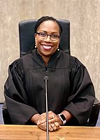
We salute Ketanji Brown Jackson, Associate Justice -designate of the United States Supreme Court
CCourt.

court

