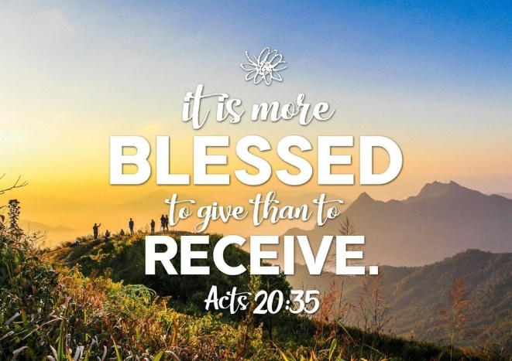
The Greater Emmanuel Temple (GETC) missionaries have been busy the last few months. Missionary Lineada Smith has partnered with Mitzvah Circle. Through this organization she was able to obtain pampers of all sizes, baby and feminine products, furniture, clothing, and other items.
Sis Smith travels monthly an hour and half round trip to collect the supplies to help those in her community, church, and the tri state area. Pampers, adult personal care items, clothing, appliances, school supplies and other miscellaneous items are stored for distribution. We thank God for a local church in Chester, PA which allows her to store items.
Through the support of City Team of Chester; the missionaries were able to distribute bookbags filled with school supplies to GETC students. Moreover, we were able to give to a Delaware mother for her children and grandchildren, and a single parent for his son. Lastly, we donated three boxes of school material to Charity Crossing Inc in Bear, DE. This organization provides necessary items to those in need in PA, MD, and DE.
Dr. Stewart delivered a box of notepads/pen sets to Churchman Village in Newark, DE. Churchman Village is a nursing home. The Activity Director was appreciative of our donation.
The missionaries continue to support Upendo, our global mission focus, in collaboration with the Upendo United Foundation. Regina Reithii started this foundation to support an orphanage in Kenya which helps 135 children ranging in age from 3 months to 19 years old. Upendo means “love “in Swahili. Feel free to visit the website to learn more www.upendounitedfoundation.org.
We contributed $50 for shipping of items to Kenya. Additionally, we donated approximately fifteen boxes of pampers of assorted sizes for the orphanage. If you would like to support us in this endeavor, please send funds to Dr. Stewart by Cash App $SAS2036, Zelle and PayPal at sstew63598@aol.com . Please note funds for global missions.
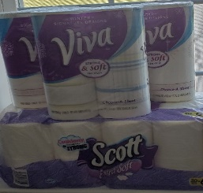
His Mission, Inc. in Kennett Square also received a monetary donation, paper products, several boxes of pampers and baby wipes.
Missionaries and members of the church helped an unemployed woman by purchasing her delicious sweet potato pies and other baked goods. GETC missionaries are always willing to help those who are trying to improve their personal lives. Pray for this young lady who lost her employment due to an accident on her job 3 years ago. She is battling with the government to get disability. She is in constant pain despite at least ten pain medication changes, therapy, chiropractor visits, primary and specialists’ appointments almost weekly and surgeries. Please pray for her to be delivered, but above all to receive salvation!
If you would like to purchase one or more desserts, contact Dr. Stewart at sstew63598@aol.com.
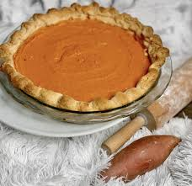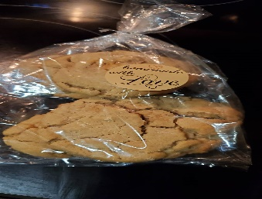
Dr. Stewart instituted Operation Smile in May. It is an ongoing campaign to encourage people unable to attend services or confined to their homes or facilities. Operation Smile involves a letter and or card campaign for any resident in a health facility, especially nursing homes, or centers for the elderly. Our major goal is to bring a smile to the clients at these institutions. Missionaries were given a list of saints and organizations to send cards of inspiration and encouragement. Correspondence is also mailed out to residents at Churchman Village in Newark, DE, Arbour Square at West Chester in West Chester, PA, Fair Acres Geriatric Center in Media, PA, and Twin Pines Health Care Center in West Grove, PA, and Brookdale Hockessin. If you would like to add an agency on the list; please notify Dr. Stewart. Limited visitations are allowed due to COVID19 precautions. Many are in isolation. It is vital during this pandemic for the residents to know that they are not alone; we are praying for them, and God is aware of their predicament.
Moreover, the missionaries send out cards and letters, make phone calls, send emails, post encouraging words on Facebook and other social media outlets. Our missionary president, Dr. Stewart, also posts Words of Encouragement on Facebook, Instagram, Twitter and shares inspirational quotes and devotionals with the missionaries and others via text or an email. Missionary Beverly Glasco post Monday Messages of Encouragement via text as well. In addition, many missionaries participate in ZOOM, YouTube, Facebook Live and other platforms for church services, bible studies and prayer meetings.
Health Awareness
As of the writing of this newsletter more than 709,000 people have died in the United States of COVID and the research indicates that most of them are people of color and now younger people. According to the Center for Disease Control African Americans and Hispanics die at a rate of over two and a half times more than whites. Of course, there are a myriad of reasons why this is the trend. Moreover, despite the availability of the vaccine, minorities tend not to get the vaccine. I would suggest that anyone unsure of the impact of the vaccine do their homework.
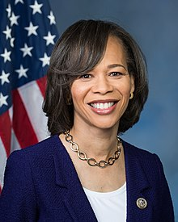
Our Black History moment recognizes Lisa Blunt Rochester. Representative Blunt was born in Philadelphia, PA. on February 10,1962. Her family later moved to Wilmington, Delaware. Her father, Ted Blunt served on the Wilmington City Council. Eventually he became the president of the council.
Lisa started her college career at Villanova University and then transferred to the University of Delaware. Her political life took off as an intern for than Delaware’s US Representative Thomas Carper in 1989. Presently, Senator Carper is Delaware’s senior senator. Blunt served the state of Delaware in various capacities before becoming its first woman and African American in the United States Congress.
Blunt is a democrat who worked on the election committee of President Joe Biden. Today she serves on the agriculture and education and workforce committees in Congress.
Knowledge is Power
I have observed so many people being woefully unprepared for doctors’ visits. I was the health advocate for my parents and my grandmother. Many times, I had to intervene during their office visits to provide critical information relevant to their health. Today health professionals are overwhelmed with Covid related matters and health regulations. Patients must be prepared to utilize their visits wisely. Below are two critical sections taken from the American Health Management Information Association to consider pre and post health visitations.
DONE BEFORE A Doctor’s VISIT Photo ID (driver’s license or other) Updated family medical information and personal information (cell/e-mail) Insurance Card List of medications (name and daily dosage) and supplements (name, brand, and daily dosage) List of allergies Immunization records (Include questions about possible new vaccinations, such as shingles, pneumonia, flu, etc. Copies of past records (including eye, dental, medical images) List of questions to ask (make sure the important ones are at the top of the list.) Advocate or note taker (Take a notebook, iPad, or smartphone to take notes. You can also make a guide for taking notes during your visit. This will prompt you to get all you need to know and ask questions if you need more information. Or bring along a friend or caretaker if you need an extra pair of eyes and ears with you.) Copay if required (credit card or cash for payment) Other doctors’ contact Information List and dates of all tests performed Results of recent tests performed from other health providers (Specialist, diagnostic test providers) Keep a symptom journal. Write down when your symptoms started, how often you experience symptoms, what makes them worse, and what you have been doing to deal with the symptoms. What hurts you? Where does it hurt? How often/long does it hurt? For example, does it hurt all day long or only some of the day? What makes it better and what makes it worse? This includes medications, activities, and food. Make sure you do all your blood work at least three to five days prior to your visit so your doctor will have all the information needed for your visit. Medical Power of Attorney
DONE AFTER A Doctor’s VISIT List of medications Copy of visit summary Prescriptions received Notes taken during visit Follow-up appointments List of tests with results pending Review all patient information (visit summary, patient portal, etc.) for accuracy Obtain copy of test results if not on visit summary Talk with doctor’s office about any outstanding test results Sign up for patient portal access (if available) List and dates of all tests performed Results of recent tests performed. Please visit https://bok.ahima.org/PdfView?oid=302739 for more information.
Remember the words of Hosea 4:6
“My people are destroyed for lack of knowledge: because thou hast rejected knowledge, I will also reject thee, that thou shalt be no priest to me: seeing thou hast forgotten the law of thy God, I will also forget thy children.”
This scripture applies to Israel’s rejection of God’s commands, but I believe it can be applicable to all types of knowledge. Let us take care of ourselves.

